EXPRESSION OF INTEREST
REEF WATER QUALITY - BURNETT GRAZING PROJECT
The Reef Water Quality – Burnett Grazing Project is offering graziers located within the Burnett priority area the opportunity to undertake Property Management Planning as well as access to one-on-one training and on-property cash incentives* to help improve groundcover and grazing management practices.
If you answer YES to ALL the following questions you may be eligible to participate in the Reef Water Quality—Burnett Grazing Project.
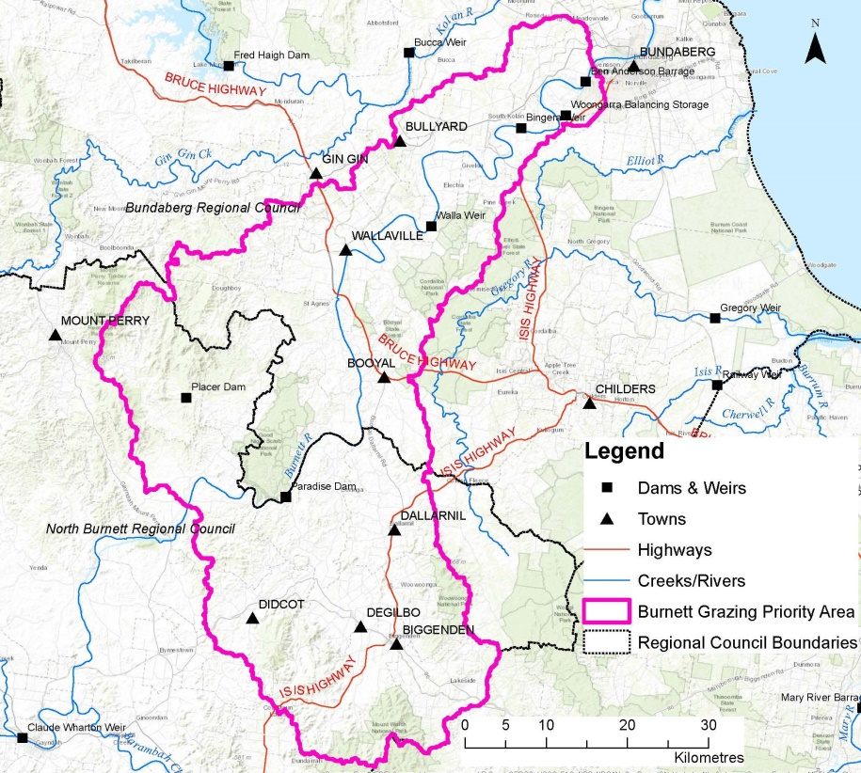
- Is your property located in the Burnett Priority Area? The priority area is in the Burnett River catchment, downstream of Paradise Dam—see map.
- Are you concerned about poor ground cover, bare patches or erosion areas on parts of your property?
- Would you like to develop a Property Management Plan (PMP) with assistance from an extension officer?
*Funding is available to graziers within the priority area who have developed a PMP as part of this project to undertake on-ground projects** to improve groundcover to reduce off-farm sediment losses. Conditions apply including maximum grant value of $15,000/applicant with minimum of 50% applicant contribution expected.
If you are interested in being considered for the development of a Property Management Plan (PMP) for your property and applying for cash incentives to undertake a project to improve groundcover and enhance grazing management practices, please provide the following contact details.

Name:
Address:
Lot on Plan/s:

Phone: Mobile: Email:
ABN:
Please answer Yes or No, for the following questions:
- Is your property located within the priority area (refer to map above)? Yes No
- Do you have areas on your property where you are concerned about poor groundcover or eroded areas? Yes No
- Would you be willing to develop a PMP with an extension officer? Yes No

**Example of eligible on-ground cash incentive projects include, fencing streambanks for stock management, installation of off-stream watering points, remediation of erosion sites or fencing different landtypes for improved grazing management.
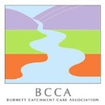
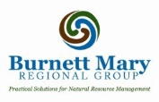
Please complete this form and return to BCCA office by 31 March 2020 Email: admin@burnettcatchment.org or Post: PO Box 8 Monto Q 4630
For further information, please phone the Burnett Catchment Care Association (BCCA): (07) 4166 3898

