CENTRAL BURNETT LANDCARE PRESENTS A
FIELD DAY
TO BE HELD

SATURDAY 1st September 2012

ITINERARY

8.30am Presentation by the makers of ‘Dr Grow it all’ – a natural organic fertiliser which improves plant health & productivity and soil health to be held at Leichhardt Lodge, 69 Leichhardt Street, Mundubbera.

9.30am Morning tea

10.00pm Biochar production demonstration & biodiesel production demonstration. Tom & Joy Denholm’s property, 216 Boondooma Road, Mundubbera.

12.00pm Lunch

1.00pm Continuation of biochar & biodiesel demonstration.

2.00pm Finish

‘Dr Grow it all’ is produced by a family company based at Cooroy. They will be introducing their product and explaining the benefits of using it.
The biochar and biodiesel making demonstrations are part of a project currently being carried out by the Central Burnett Landcare group.

This day is free of charge. Lunch & Morning Tea provided. Please RSVP by Wednesday, 29th August for catering purposes. Phone Marion Denholm on 41 654 531.

Funding for this day has come from the Federal Government through their ‘Caring for our Country’ programme.
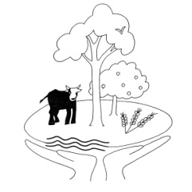

CENTRAL BURNETT
LANDCARE

